Estelle Mae (Morrison) Kirchner
October 21, 1936 – October 9, 2008

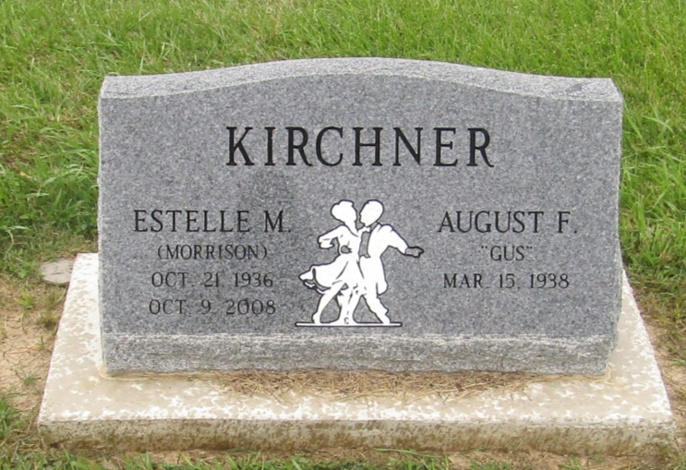

Indiana, Death Certificates, 1899-2011

Name: Estelle Mae Kirchner
[Estelle Mae Kurchner]
Maiden Name: Morrison
Gender: Female
Race: White
Age: 71
Marital status: Married
Birth Date: 21 Oct 1936
Birth Place: Redwing, Minnesota
Death Date: 9 Oct 2008
Death Place: Ossian, Wells, Indiana, USA
Father: Ernie Morrison
Mother: Stella Pearson
Spouse: August Kirchner, informant
Disposition: Science Care, Aurora, CO

