Andrew R. Johnston
June 6, 1838 – October 19, 1913

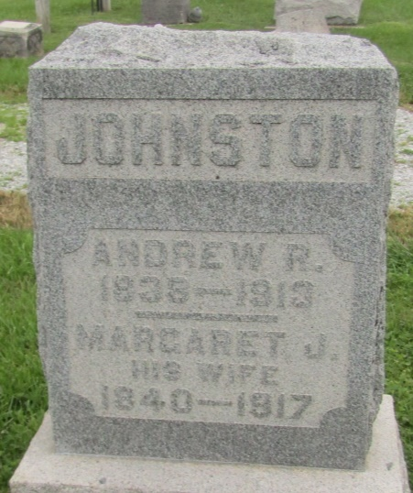

Andrew R. Johnston
in the Indiana, U.S., Death Certificates, 1899-2011
Name: Andrew R. Johnston
Gender: Male
Race: White
Age: 75
Marital status: Married
Birth Date: 6 Jun 1838
Birth Place: Ohio
Death Date: 19 Oct 1913
Death Place: Jefferson, Wells, Indiana, USA
Father: Thomas Johnston
Mother: Martha Riddle
Spouse: Margret
Informant: Sherman; Ossian, Indiana
Burial: October 21, 1913; Prospect Cemetery

