Cecelia M. (Davison) Jackson
July 30, 1903 – March 14, 1986

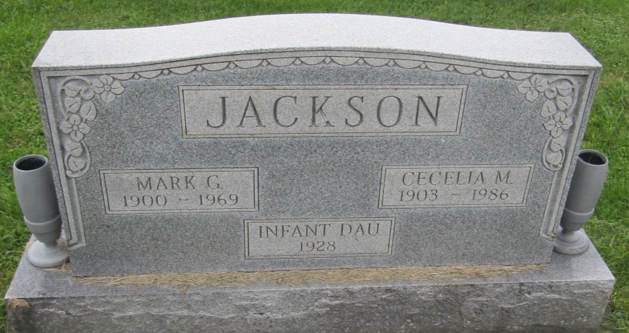

Cecelia M Jackson
in the Indiana, U.S., Death Certificates, 1899-2011
Name: Cecelia M Jackson
[Cecelia M Davison]
Gender: Female
Race: White
Age: 82
Marital status: Widowed
Birth Date: 30 Jul 1903
Birth Place: Indiana
Death Date: 14 Mar 1986
Death Place: Fort Wayne, Allen, Indiana, USA
Father: Braton Davison
Mother: Zoe Shorts
Informant: Madalyn Brumbaugh; daughter; Markle, Indiana
Burial: March 17, 1986; Prospect Cemetery; Wells County, Indiana

