Betty E. (Cotton) Inman
July 21, 1919 – January 10, 2014

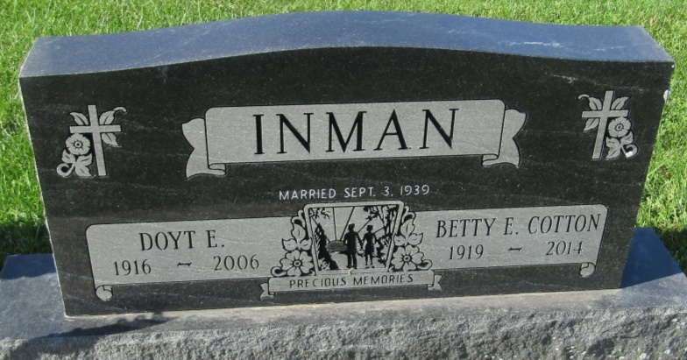

Betty E. Inman, 94, of Bluffton, passed away at 9:30 a.m. Friday, Jan. 10, 2014 at Christian Care Retirement Center in Bluffton. Betty was born July 21, 1919 in Ossian a daughter of Forst G. and Cleona (Hoover) Cotton. She has lived most of her life in Wells County, living in Uniondale for over 27 years. On Sept. 3, 1939 she married Doyt E. Inman.
He preceded her in death on Oct. 6, 2006. She was a homemaker and also worked at the Bluffton Sears Store for 23 years, retiring in 1979. She was a member of the First United Methodist Church in Bluffton.
She is survived by her son, Lane S. (Sidonie) Inman of Fort Wayne; along with five grandchildren, Terena (Scott) Kumfer, Chad (Ashley) Inman, Scott (Julie) Inman, Kurt (Jennifer) Keller and Lesli (Lou "JR.") Landerer along with 13 great- grandchildren and several nieces and nephews. She was preceded in death by an infant daughter, Sara Lee Inman; and siblings, Eudora Jane Yager and Lyle Cotton.
A service to celebrate Betty's life is 3 p.m. Sunday, Jan. 12, 2014, at the First United Methodist Church in Bluffton with calling two hours prior to service; Rev. Greg Rittenhouse officiating. Burial will follow at Prospect Cemetery in Uniondale, Indiana.
Memorials in Betty's memory can be made to the First United Methodist Church.

Thoma/Rich Funeral Home, Wells County, Indiana
January 11, 2014

