Maurice J. Hoover
October 6, 1901 – November 12, 1983

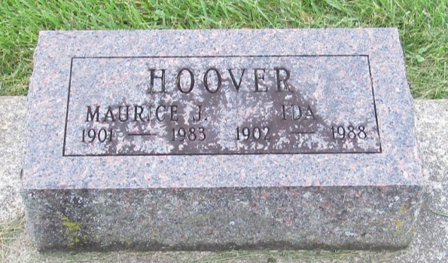

Maurice J. Hoover
in the Indiana, U.S., Death Certificates, 1899-2011
Name: Maurice J. Hoover
Gender: Male
Race: White
Age: 82
Marital status: Married
Birth Date: 6 Oct 1901
Birth Place: Indiana
Death Date: 12 Nov 1983
Death Place: Plymouth, Marshall, Indiana, USA
Father: Marion Hoover
Mother: Minnie Shepherd
Spouse: Gertrude Ida Wilson
Informant: Gertrude Hoover; wife; Plymouth, Indiana
Burial: November 15, 1983; Prospect Cemetery; Uniondale, Indiana

