Mary Jane (Ady) Hoopengardner
February 26, 1846 – 1879

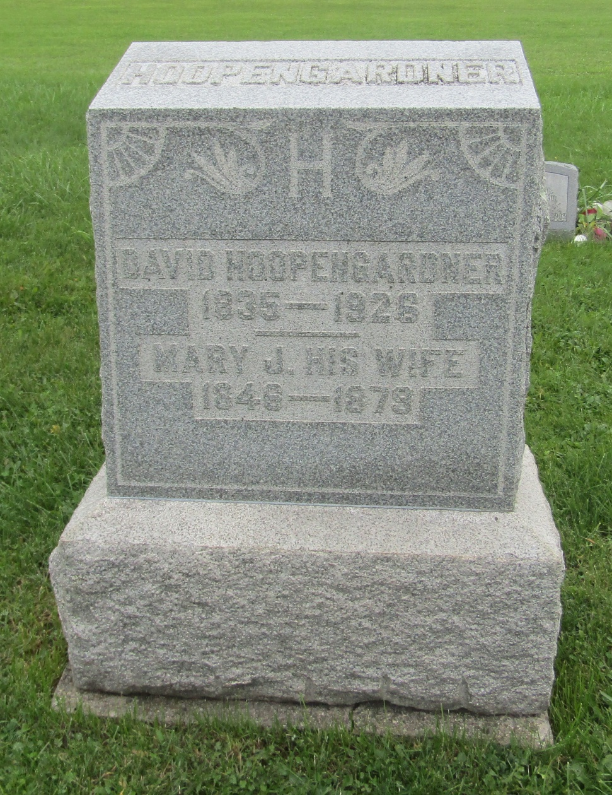

No further information at this time.

