Etta M. (Osborn) Heckman
November 8, 1865 – March 21, 1936

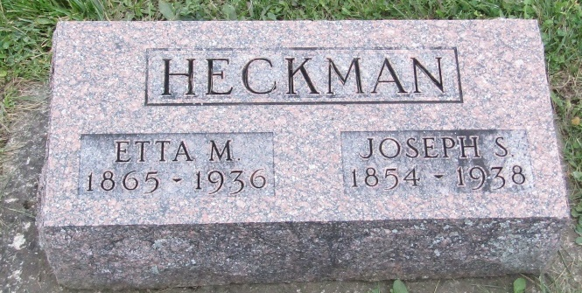

Mrs. Joseph Heckman 70, died at her home in Ossian; Born in Union Twp., to Levi and Catherine Ashburn (Osborn). Her marriage took place in Uniondale on 20 Feb 1894.
Surviving is husband and five children, Fred Heckman, of Antwerp, OH., Chester Osborn of Uniondale;, Mrs. Ernest Goette and Mrs. Roy Harmon of Ft. Wayne; Mrs. Crittendon Mason of Lebanon; a sister Mrs. Frank Dickey, near Uniondale; two brothers, Elias Osborn of Kingsland; and William Osborn near Ossian, and 14 grandchildren.
Burial in Prospect Cemetery.

Bluffton News-Banner, Wells County, Indiana
March 22, 1936

*****
Indiana, U.S., Death Certificates, 1899-2011
Name: Etta M Heckman
[Etta M Osborn]
Gender: Female
Race: White
Age: 70
Marital status: Married
Birth Date: 8 Nov 1865
Birth Place: Indiana
Death Date: 21 Mar 1936
Death Place: Ossian, Wells, Indiana, USA
Father: Levi Osborn
Mother: Catherine Ashburn
Spouse: Joseph Heckman
Informant: Joseph Heckman; Ossian, Indiana
Burial: March 23, 1936; Prospect Cemetery

