Robert L. Hatfield
January 14, 1868 – July 7, 1953

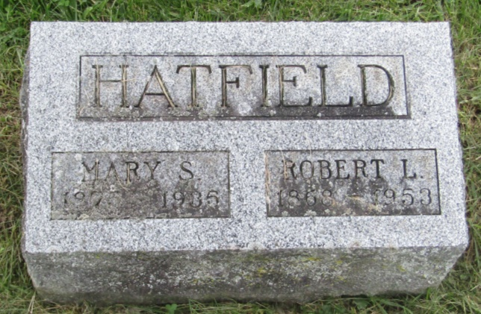

Robert Hatfield Claimed by Death

Robert L. Hatfield, 84, died at 9 o'clock this morning at the home of a daughter, Mrs. Charles Wilson, four and one-half miles west of Ossian. He had been bedfast two weeks and death came very suddenly.
The decedent was born in Union Township, Wells County, to John and Ann Harter Hatfield. His wife died in 1935.
Surviving are two sons, James N. of near Ossian and Halden L. of Ossian; five daughters, Mrs. Charles Wilson, near Ossian, Mrs. Halden Hunter of Ossian, Mrs. Harold Byrd of Fort Wayne, Mrs. Charles Brubaker of South Whitley and Miss Dorothy Hatfield of Madison, Wis.; 24 grandchildren and 23 great-grandchildren.
The body was removed to the Elzey & Son Funeral Home at Ossian where friends may call after 6 o'clock Wednesday evening. The body will be taken at 1 o'clock Thursday afternoon to the Prospect Methodist Church where services will be conducted at 2 0'clock with rev. Walter Meacham officiating. Burial will be in the Prospect Cemetery.

Bluffton News-Banner, Wells County, Indiana
July 7, 1953

*****
Indiana, U.S., Death Certificates, 1899-2011
Name: Robert E Hatfield
Gender: Male
Race: White
Age: 84
Marital status: Married
Birth Date: 14 Jan 1869 [sic]
Birth Place: Indiana
Death Date: 7 Jul 1953
Death Place: Rural, Wells, Indiana, USA
Father: John Hatfield
Mother: Ann Harter
Informant: Halder Hatfield; Ossian, Indiana
Burial: July 9, 1953; Prospect Cemetery; Ossian, Indiana

