Willis Harshman
February 20, 1894 – August 4, 1894

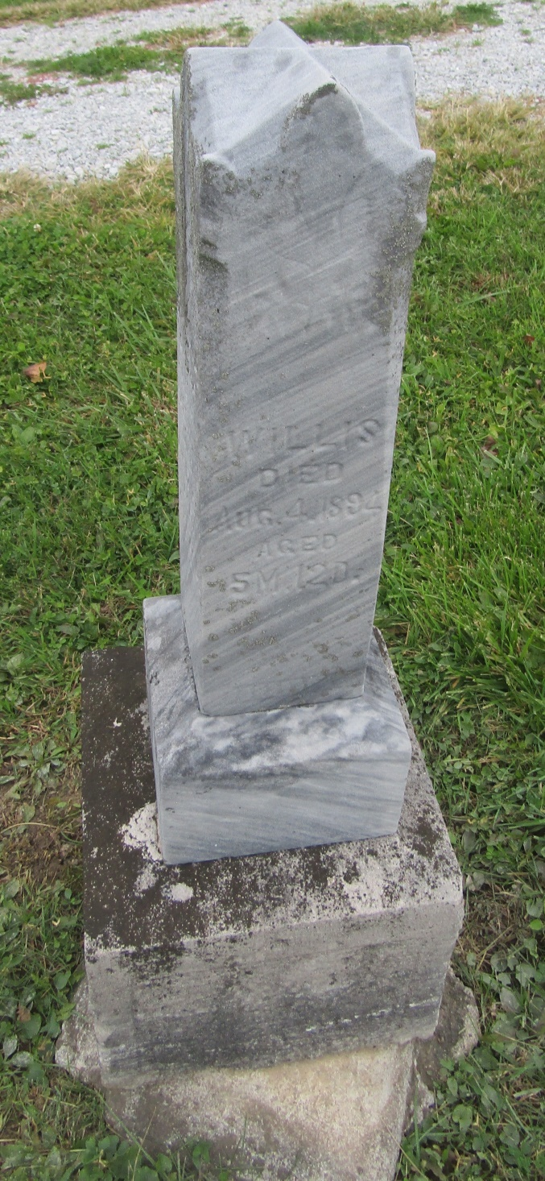

No further information at this time.

