Hattie F. (Wasson) Harshman
November 17, 1895 – June 9, 1985

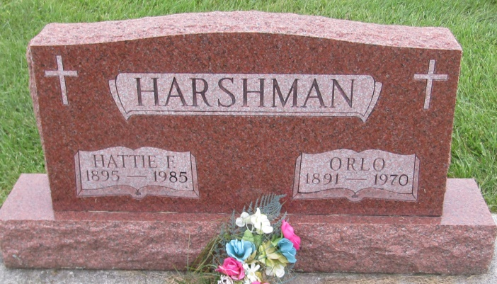

Hattie F Harshman
in the Indiana, U.S., Death Certificates, 1899-2011
Name: Hattie F Harshman
[Hattie F Wasson]
Gender: Female
Race: Caucasian (White)
Age: 89
Marital status: Widowed
Birth Date: 17 Nov 1895
Birth Place: Indiana
Death Date: 9 Jun 1985
Death Place: Bluffton, Wells, Indiana, USA
Father: David T Wasson
Mother: Martha J Flemming
Spouse: Orlo Harshman; deceased
Informant: Paul Harshman; son; Bluffton, Indiana
Burial: June 12, 1985; Prospect Cemetery; Uniondale, Indiana

