James Gorman
September 20, 1867 – October 31, 1868

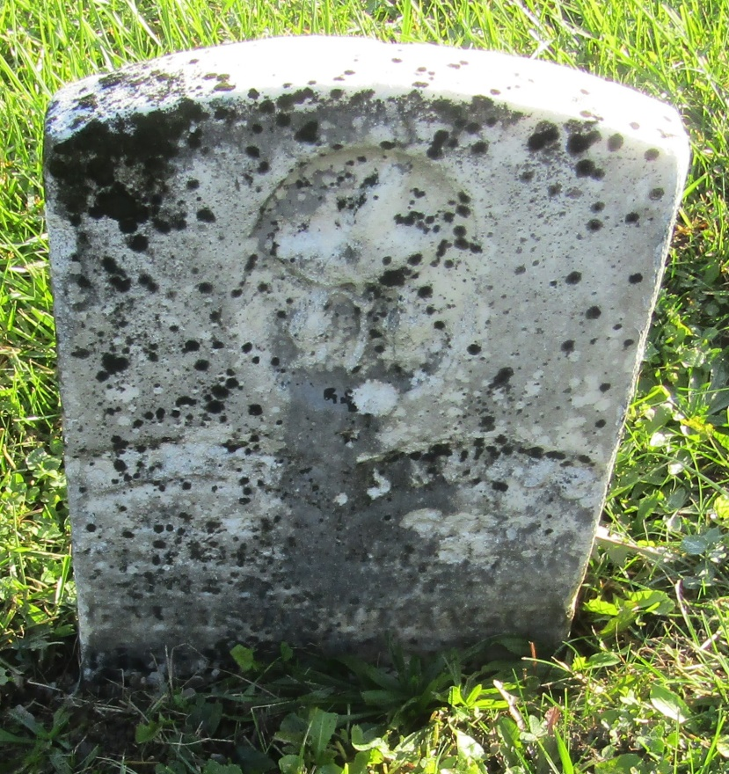

No further information at this time.

