Anna (Osborn) Gorman
1836 – 1877

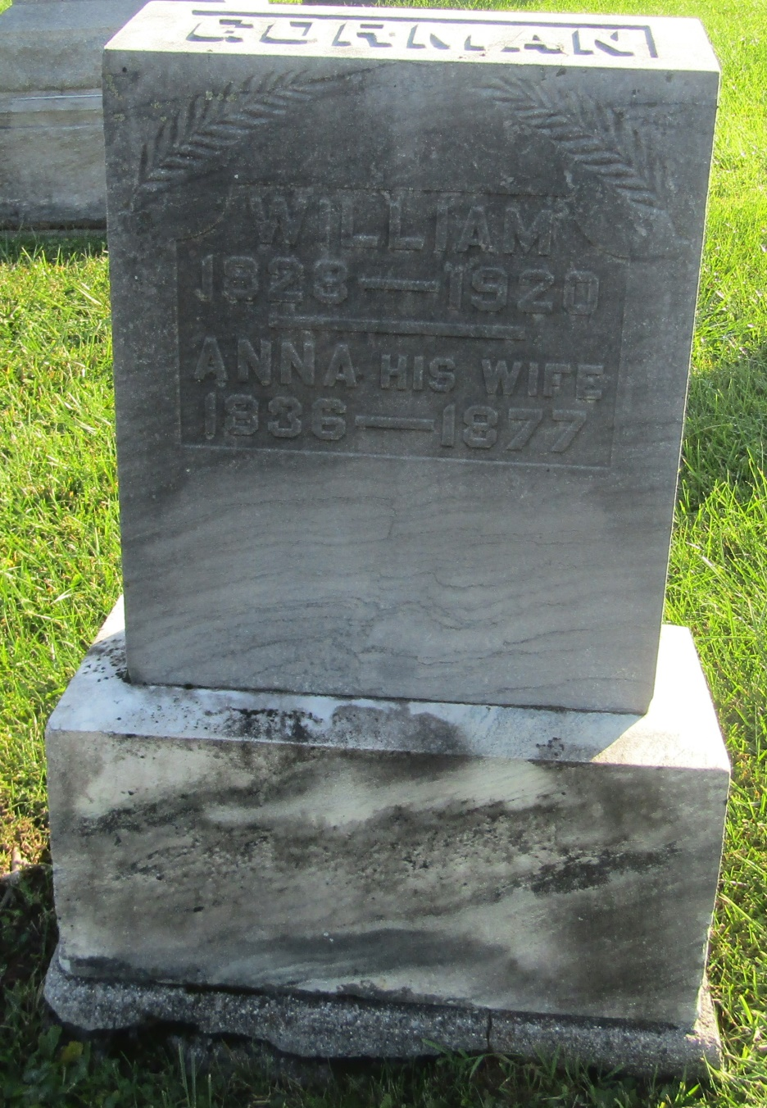

No further information at this time.

