Otto Lowell Fusselman
February 9, 1877 – May 1, 1929

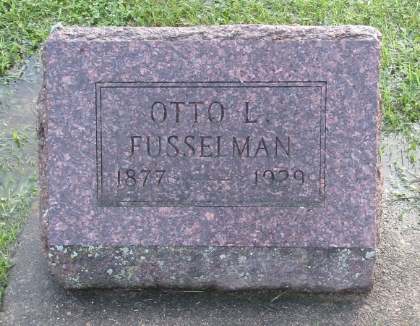

Ottis L. Fusselman
in the Indiana, U.S., Death Certificates, 1899-2011
Name: Ottis L. Fusselman
Gender: Male
Race: White
Age: 52
Marital status: Married
Birth Date: 9 Feb 1877
Birth Place: Indiana
Death Date: 1 May 1929
Death Place: Union, Wells, Indiana, USA
Father: George Fusselman
Mother: Josephine Templeton
Spouse: Rose Fusselman
Informant: Charles Fusselman; Fort Wayne, Indiana
Burial: May 2, 1929; Prospect Cemetery

