Charles Thurlow Folk
October 28, 1890 – January 3, 1963

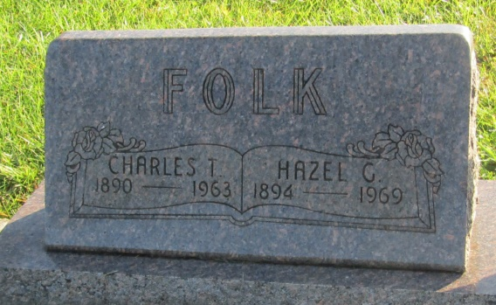

Charles T Folk
in the Indiana, U.S., Death Certificates, 1899-2011
Name: Charles T Folk
Gender: Male
Race: White
Age: 72
Marital status: Married
Birth Date: 28 Oct 1890
Birth Place: Indiana
Death Date: 3 Jan 1963
Death Place: Fort Wayne, Allen, Indiana, USA
Father: Frank Folk
Mother: Liberta Brickley
Informant: Mrs. Dorma Greene; daughter; Markle, Indiana
Burial: January 6, 1963; Prospect Cemetery; Wells County, Indiana

