Edward Elberson
April 26, 1867 – January 26, 1944

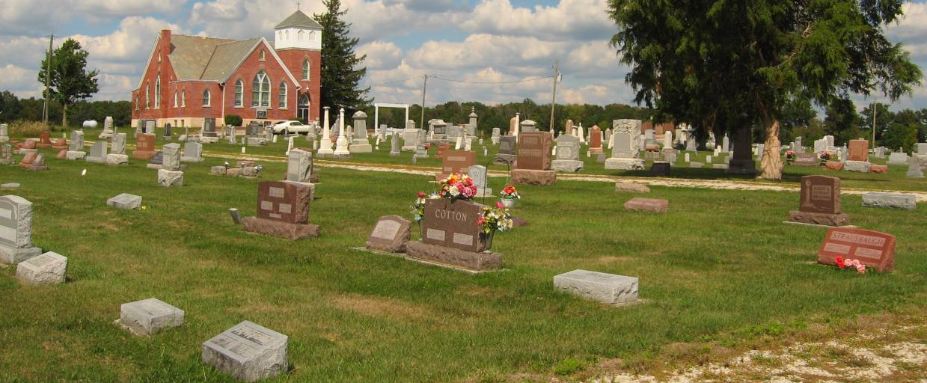
Photo by Tombstoner & Family

Edward Elberson
in the Indiana, U.S., Death Certificates, 1899-2011
Name: Edward Elberson
Gender: Male
Race: White
Age: 76
Marital status: Widowed
Birth Date: 26 Apr 1867
Birth Place: Union Dale Ind
Death Date: 26 Jan 1944
Death Place: Fort Wayne, Allen, Indiana, USA
Father: Jonathan Elberson
Mother: Catherine Bergman
Informant: Mrs. Rose Brickley
Burial: January 29, 1944; Prospect Cemetery; Ossian, Indiana

