Catharine (Bergman) Elberson
March 7, 1845 – July 21, 1907

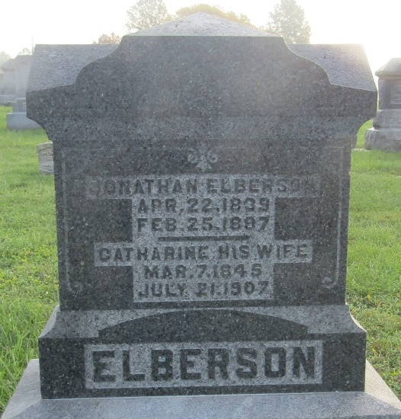

Catharine Elberson
in the Indiana, U.S., Death Certificates, 1899-2011
Name: Catharine Elberson
[Catharine Bergman]
Gender: Female
Race: White
Age: 62
Marital status: Widowed
Birth Date: 7 Mar 1845
Birth Place: Wells Ind
Death Date: 21 Jul 1907
Death Place: Uniondale, Wells, Indiana, USA
Father: J Bergman
Mother: Not known
Informant: Rosa Brickley; Uniondale, Indiana
Burial: July 23, 1907; Prospect Cemetery

