Robert Earl
November 4, 1857 – November 30, 1900

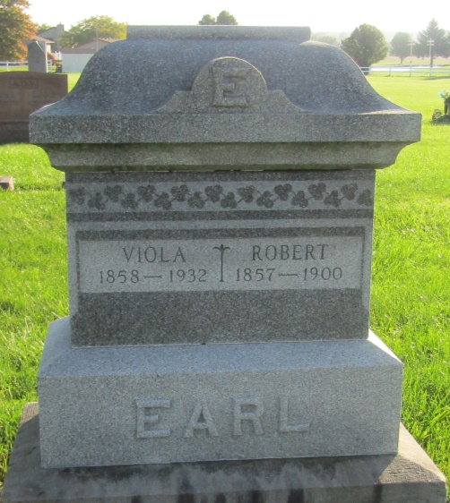

Robert Earl
in the Indiana, U.S., Death Certificates, 1899-2011
Name: Robert Earl
Gender: Male
Race: White
Age: 43 years, 0 months, 26 days
Birth Date: abt 1857
Birth Place: Indiana Wells Co
Death Date: 30 Nov 1900
Death Place: Jonesville, Wells, Indiana, USA
Father: Charles Earl
Mother: Margaret Cartright
Informant: Viola Earl; Zanesville, Indiana
Burial: December 2, 1900; Prospect Church

