Edith Mae (Scott) Duffey
July 6, 1912 – September 3, 1982

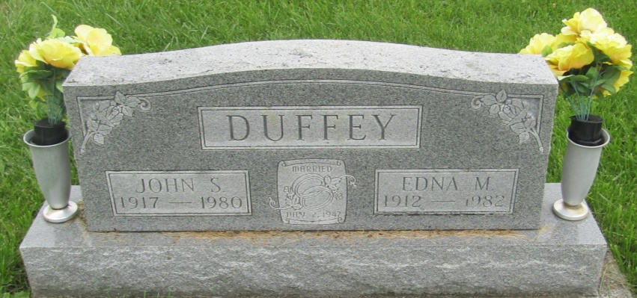

Edna Mae Duffey
in the Indiana, U.S., Death Certificates, 1899-2011
Name: Edna Mae Duffey
[Edna Mae Scott]
Gender: Female
Race: White
Age: 70
Marital status: Widowed
Birth Date: 6 Jul 1912
Birth Place: IN
Death Date: 3 Sep 1982
Death Place: Bluffton, Wells, Indiana, USA
Father: James A. Scott
Mother: Devona Graham
Informant: John S. Duffey; son; Fort Wayne, Indiana
Burial: September 6, 1982; Prospect Cemetery; Ossian, Indiana

