John Double
December 25, 1825 – January 18, 1904

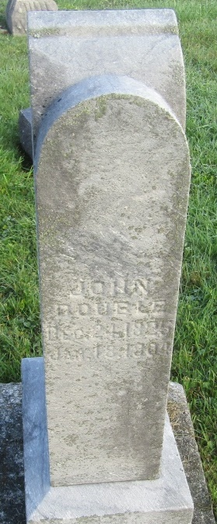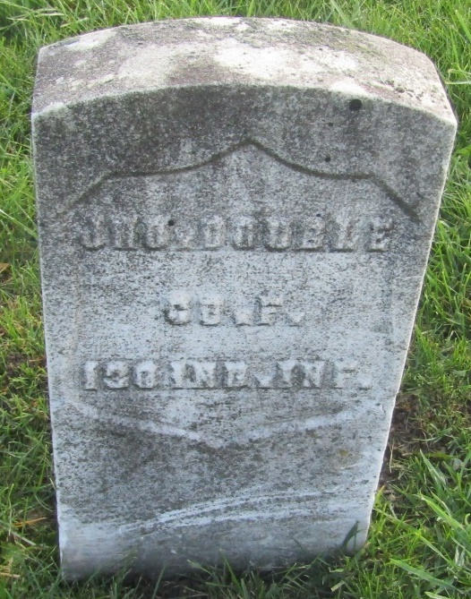

John Double
in the Indiana, U.S., Death Certificates, 1899-2011
Name: John Double
Gender: Male
Race: White
Age: 78
Marital status: Widowed
Birth Date: 25 Dec 1825
Birth Place: Ohio
Death Date: 18 Jan 1904
Death Place: Ossian, Wells, Indiana, USA
Father: Samuel Double
Mother: Windferd Masters
Spouse: Barabra
Informant: Wm. Double; Ossian, Indiana
Burial: January 19, 1904; Prospect Cemetery
*****

JOHN DOUBLE (1824-1904) CO F 130th IND INF (CW)
John Double
Regiment Name 130 Indiana Infantry
Side Union
Company F
Soldier's Rank_In Pvt.
Soldier's Rank_Out Pvt.

