Ronald Eugene Dickey
May 30, 1940 – May 31, 1940

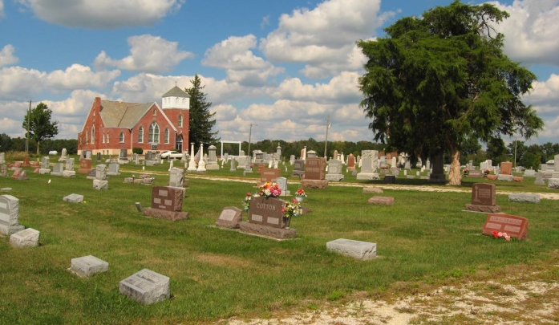

R. Eugene Dickey, infant son of Mr. and Mrs. Herman Dickey of 4207 South Lafayette Street, one of twins born Thursday morning at the Lutheran Hospital, died at 4:10 o'clock yesterday afternoon.
He is survived by his parents, grandparents, Mr. and Mrs. Frank Dickey of near Uniondale and Mrs. Jane Brand of Auburn, Cal.; and two brothers, the other twin, Donald Edwin and Richard.
The body was taken to the Elzey & Son Funeral Home at Ossian and will be returned this morning to the home of an aunt, Mrs. Ralph Thompson of 1511 Greene Street, where a short service will be held. Burial will be in the Prospect Cemetery near Uniondale.
Journal-Gazette, Allen County, Indiana
June 1, 1940
*****

Indiana, U.S., Death Certificates, 1899-2011
Name: Infant Dickey
Gender: Male
Race: White
Age: 1 day
Marital status: S
Birth Date: 30 May 1940
Birth Place: Fort Wayne Allen County Indiana
Death Date: 31 May 1940
Death Place: Fort Wayne, Allen, Indiana, USA
Father: Herman E Dickey
Mother: Ethel L Brand
Informant: Mrs. H. E. Dickey
Burial: June 1, 1940; Prospect Cemetery

