Verdella M. (Neuhauser) DeWalt
August 9, 1920 – November 15, 1996

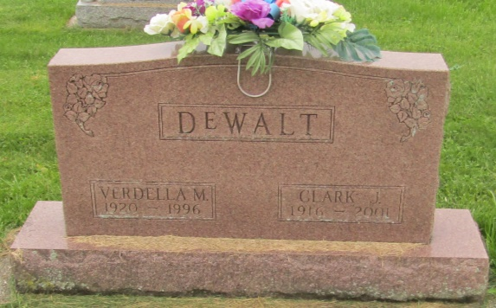

Verdella M DeWalt
in the Indiana, U.S., Death Certificates, 1899-2011
Name: Verdella M DeWalt
[Verdella M Neuhauser]
Gender: Female
Race: Caucasian (White)
Age: 76
Marital status: Married
Birth Date: 9 Aug 1920
Birth Place: Wells County, In
Death Date: 15 Nov 1996
Death Place: Fort Wayne, Allen, Indiana, USA
Father: Henry Neuhauser
Mother: Laura Crum
Spouse: Clark J Dewalt
Informant: Clark J. DeWalt; husband; Fort Wayne, Indiana
Burial: November 18, 1996; Prospect Cemetery; Uniondale, Indiana

