Herman W. Curry
July 20, 1906 – January 27, 1980

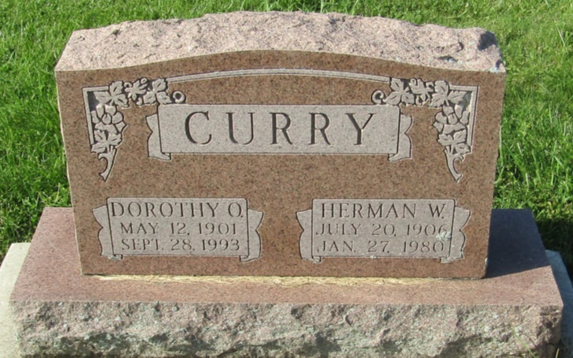

Herman W. Curry
in the Indiana, U.S., Death Certificates, 1899-2011
Name: Herman W. Curry
Gender: Male
Race: White
Age: 73
Marital status: Married
Birth Date: 20 Jul 1906
Birth Place: Ind.
Death Date: 27 Jan 1980
Death Place: Ft. Wayne, Allen, Indiana, USA
Father: James H. Curry
Mother: Lucy Tucker
Spouse: Dorothy Osborn
Informant: Dorothy Curry; Fort Wayne, Indiana
Burial: January 29, 1980; Prospect Cemetery; Wells County, Indiana

