Dr. Phyllis M. (Wilson) Confer
January 8, 1930 – August 8, 1996

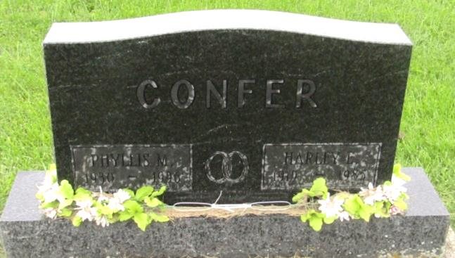

Dr Phyllis Wilson Confer
in the Indiana, U.S., Death Certificates, 1899-2011
Name: Dr Phyllis Wilson Confer
[Dr Phyllis Wilson Wilson]
Gender: Female
Race: Caucasian (White)
Age: 66
Marital status: Widowed
Birth Date: 8 Jan 1930
Birth Place: Wells County, Indiana
Death Date: 8 Aug 1996
Death Place: Fort Wayne, Allen, Indiana, USA
Father: Charles A Wilson
Mother: Margaret R Hatfield
Informant: Sarah Confer; daughter; Markle, Indiana
Burial: August 12, 1996; Prospect Cemetery; Uniondale, Indiana

