Lydia Ann (Schoonover) Byrd
October 20, 1831 – April 28, 1872

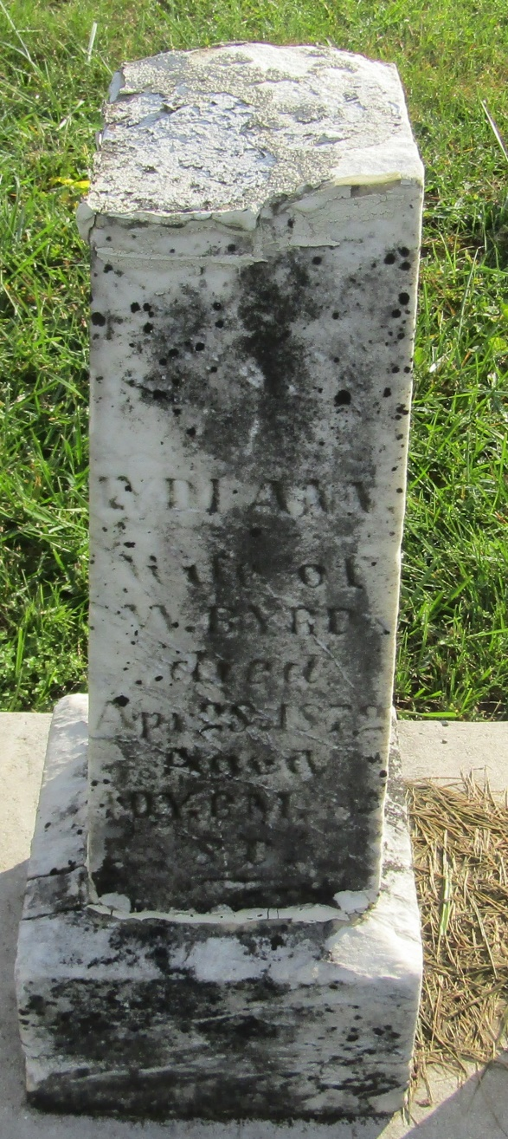

No further information found at this time

