Infant Daughter Byrd
May 12, 1887 – May 12, 1887

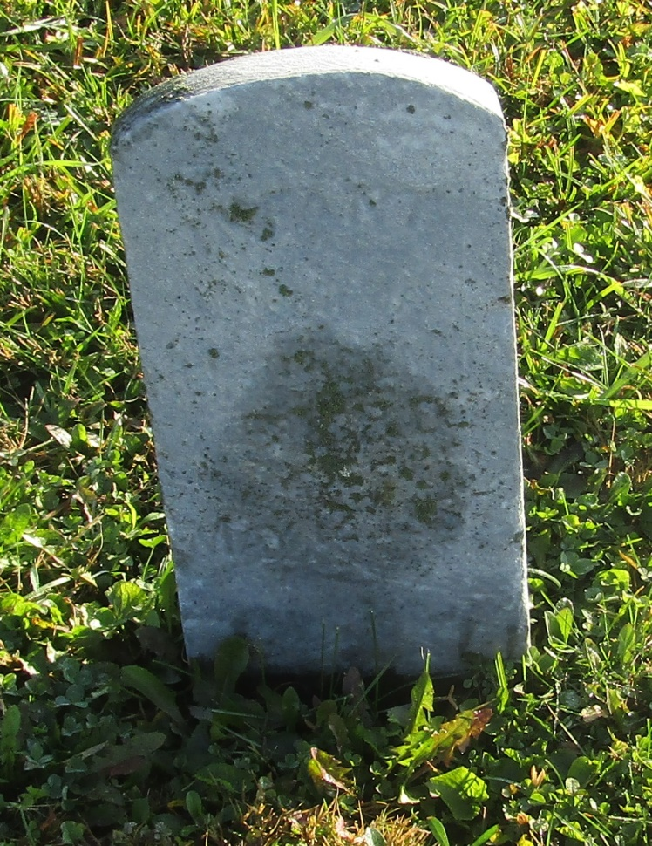

No further information found at this time

