Emma Francilia (Rogers) Byrd
March 17, 1863 – April 28, 1906

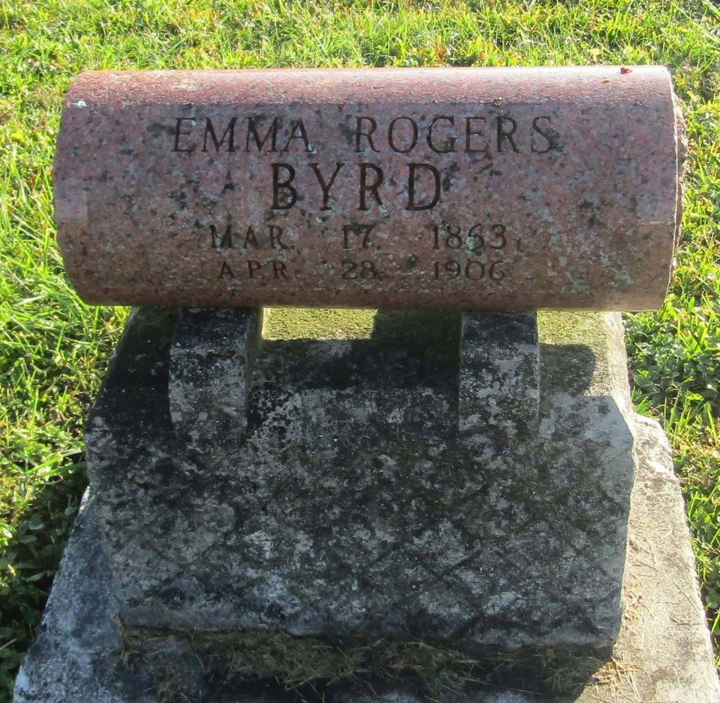

No further information found at this time

