Edith Byrd
August 12, 1891 – August 24, 1891

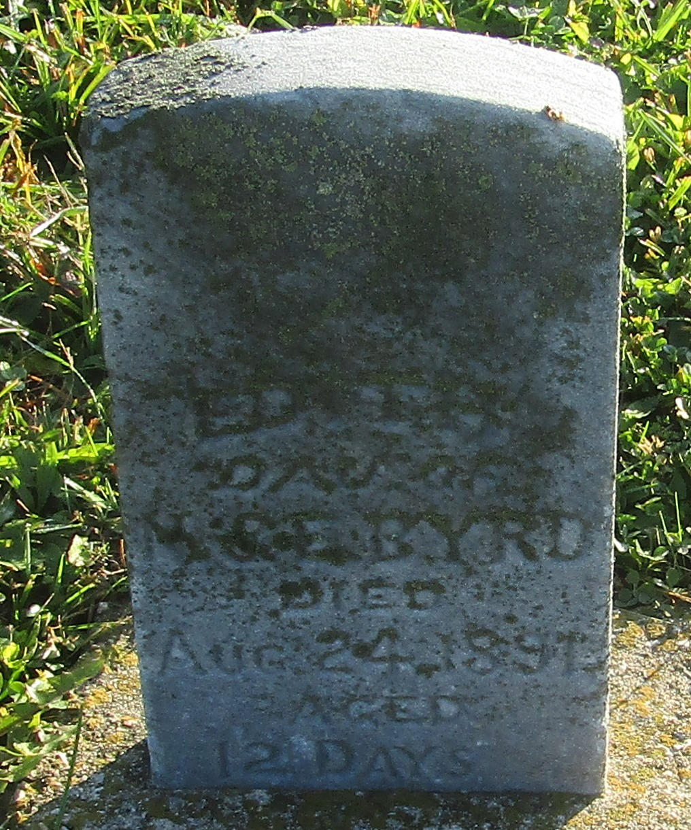

No further information found at this time

