Andrew Jackson Brickley
December 9, 1866 – February 17, 1942

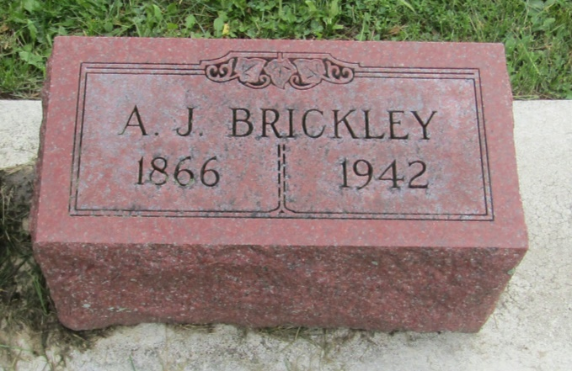

Andrew J Brickley
in the Indiana, U.S., Death Certificates, 1899-2011
Name: Andrew J Brickley
Gender: Male
Race: White
Age: 75
Marital status: Divorced
Birth Date: 9 Dec 1866
Birth Place: Markel, Ind
Death Date: 17 Feb 1942
Death Place: Fort Wayne, Allen, Indiana, USA
Father: John W Brickley
Mother: Kathryn Haiflich
Informant: Vaughn Brickley
Burial: February 19, 1942; Prospect Cemetery; Ossian, Indiana

