Mary Jane (Todd) Bowman
September 26, 1840 – April 24, 1878

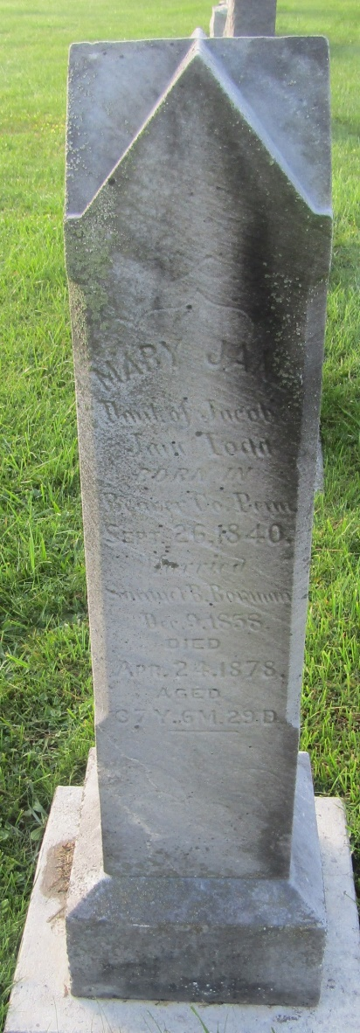

No further information found at this time

