Catherine Geneva (Carver) Bobay-Moody
December 16, 1921 – April 12, 2017

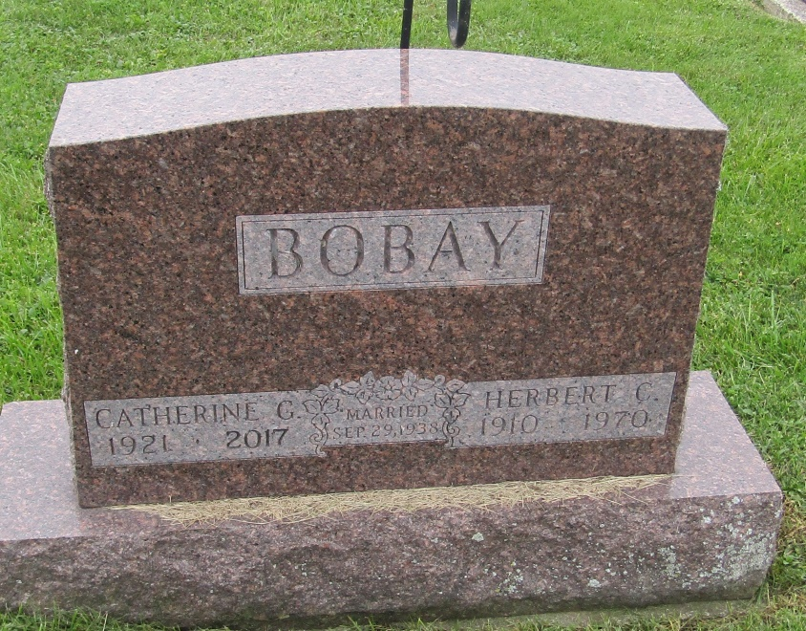

Catherine G. Moody, 95, of Fort Wayne passed away on April 12, 2017 at her home. She was born on December 16, 1921, in Wells County, a daughter of the late Harry, Sr. and Orva M. (Roe) Carver. She retired from County Line Cheese in Auburn. She loved being around friend and family at all times. She enjoyed a good game of euchre, crocheting afghans, fishing, and listening to old country music and bluegrass.
Surviving family include her daughter, Colleen (Steve) McDougall; son, James Bobay; step daughters, Sue (Dave) Prescot and Jane Tracey; step son-in-law, Herb Kramer; two grandsons, Michael (Angie) McDougall and Matthew (Leslie) McDougall; seven step grandchildren, Kathy (Troy) Gouwens, Debbie Kramer-Hall, Kathy (Greg) Friend, Brent (Kylie) Prescot, Dan Kramer, Tommie Tracey, David Tracey; two great granddaughters, Dana and Brianna McDougall; four great grandsons, Kevin, Austin, Kayden, Wyatt McDougall; 11 step great grandchildren; brother, Paul (Rosie) Carver; numerous nieces and nephews; and her Steinke Resort family and friends. She was also preceded in passing by her first husband, Herbert Bobay in 1970, second husband, Carl Moody in 1988, and her companion of 21 years, Lawrence Croy in 2012; siblings, Fredia Carver, Charles Carver, Fran Robertson, Loyd Carver, Erma Burkholder, Harry Carver, Jr., and Margie Ditmar; and her step daughter, Ann Kramer.
Funeral service will be 2:00 pm on Wednesday, April 19, 2017 at Elzey-Patterson-Rodak Funeral Home, 120 West Mill St., Ossian with visitation one hour prior with Chaplain Carolyn Sherrill officiating. Visitation will also be from 2-4 and 6-8 pm on Tuesday, April 18, 2017 at the funeral home. Burial will be in Prospect Cemetery, Uniondale.
In lieu of flowers, memorial may be made to the family or two of Catherine’s favorite charities, Down Syndrome of Louisville, 5001 S. Hurstbourne Parkway, Louisville, Kentucky 40299 or Batten Disease Support and Research Association (BDSRA.org).
The family would like to thank the staff at Visiting Nurse & Hospice Home for the excellent care that they provided for Catherine in her final days.

Elzey Funeral Home, Wells County, Indiana
April 13, 2017

*****
Indiana, U.S., Marriage Certificates, 1960-2005
Name: Catherine Geneva Bobay
Gender: Female
Age: 50
Birth Date: abt 1922
Birth Place: Indiana
Marriage Date: 26 Aug 1972
Marriage Place: Fort Wayne, Allen, Indiana, USA
Spouse: Carl Irvin Moody
Certificate Number: 72-033789
*****
U.S., Cemetery and Funeral Home Collection, 1847-Current
Name: Catherine G. Moody
[Catherine G. Carver]
Gender: Female
Death Age: 95
Birth Date: 16 Dec 1921
Birth Place: Wells County
Death Date: 12 Apr 2017
Death Place: Fort Wayne
Burial Date: 19 Apr 2017
Burial Place: Uniondale
Father: Harry Carver
Mother: Orva M. Carver
Spouse: Herbert Bobay
Child: Colleen McDougall, James Bobay
Siblings: Charles, Fran, Loyd, Erma, Fredia, Margie, Harry, Paul Carver

