Herbert Charles Bobay
December 17, 1910 – July 4, 1970

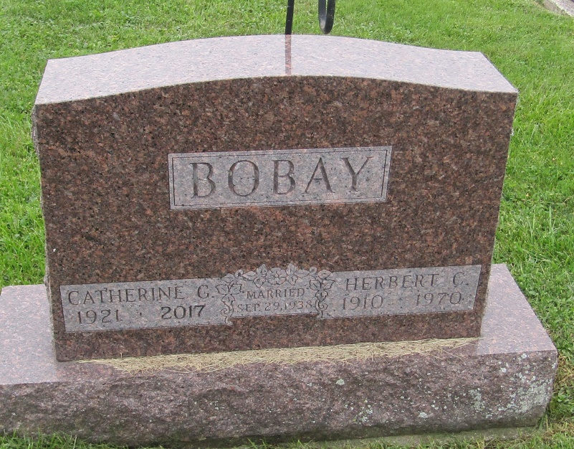

Herbert C. Bobay, 59, of Fort Wayne, Indiana died Saturday at his home. A native and lifelong resident of Fort Wayne, he is survived by his wife, Catherine, one son, one daughter, his mother, three sisters and one grandchild.
Funeral services will be Wednesday at the Mungovan & Sons Lakeside Chapel; burial in Prospect Cemetery in Wells County.

Bluffton News-Banner, Wells County, Indiana
July 4, 1970

*****
Indiana, U.S., Death Certificates, 1899-2011
Name: Herbert C Bobay
Gender: Male
Race: White
Age: 59
Marital status: Married
Birth Date: 17 Dec 1910
Birth Place: Indiana
Death Date: 4 Jul 1970
Death Place: Fort Wayne, Allen, Indiana, USA
Father: Charles Bobay
Mother: Cecelia Urbine
Spouse: Catherine G Carver
Informant: Catherine Bobay; wife; Fort Wayne, Indiana
Burial: July 8, 1970; Prospect Cemetery; Ossian, Indiana

