Charles C. Black
March 28, 1901 – August 22, 1901

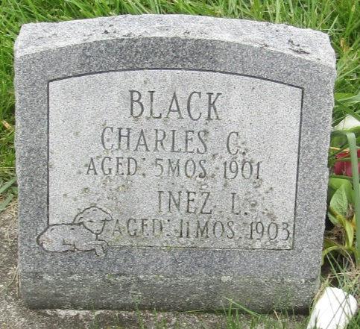

Charles C Black
in the Indiana, U.S., Death Certificates, 1899-2011
Name: Charles C Black
Gender: Male
Race: White
Age: 4 months, 25 days
Marital status: Single
Birth Date: abt 1901
Birth Place: Uniondale
Death Date: 22 Aug 1901
Death Place: Union, Wells, Indiana, USA
Father: Wm H Black
Mother: Rosy E Nickelson
Informant: J. D. Hile; Uniondale, Indiana
Burial: August 23, 1901; Prospect Cemetery

