William Henderson Ashburn
July 13, 1831 – February 12, 1902

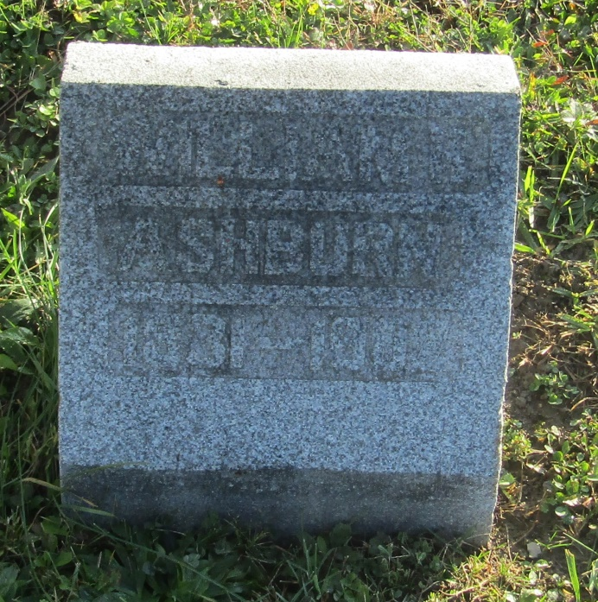

William Henderson Ashburn
in the Indiana, U.S., Death Certificates, 1899-2011
Name: William Henderson Ashburn
Gender: Male
Race: White
Age: 70
Marital status: Widowed
Birth Date: 13 Jul 1831
Birth Place: Columbiana Co Ohio
Death Date: 12 Feb 1902
Death Place: Jefferson, Wells, Indiana, USA
Father: Joseph Ashburn
Mother: Elisabeth Hart
Informant: Hannah A. Miller; daughter; Ossian, Indiana
Burial: February 15, 1902; Prospect Cemetery

