Margret Alice (Wilson) Anthony
September 7, 1854 – December 28, 1941

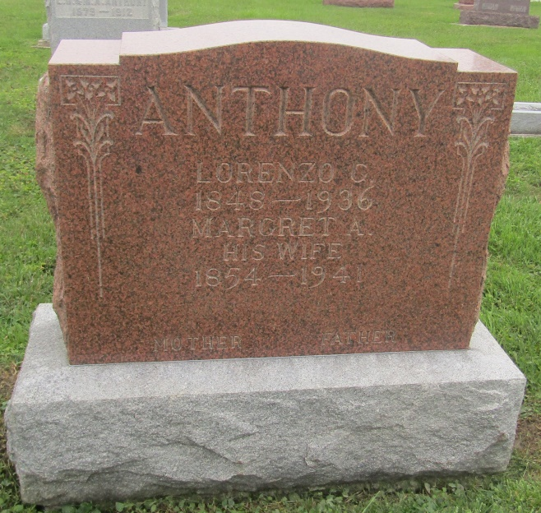

Indiana, U.S., Marriages, 1810-2001

Name: Margaret A Wilson
Gender: Female
Event Type: Marriage Registration (Marriage)
Marriage Date: 10 Oct 1872
Marriage Place: Indiana, United States
Spouse: Lorenzo G Anthony
Page: 254
FHL Film Number: 002318462

