Lorenzo G. Anthony
May 7, 1848 – December 26, 1936

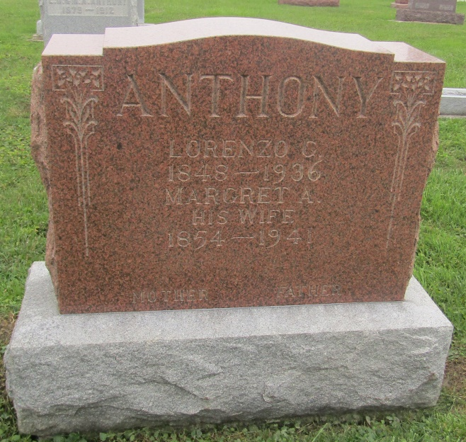

Lorenzo G Anthony
in the Indiana, U.S., Death Certificates, 1899-2011
Name: Lorenzo G Anthony
Gender: Male
Race: White
Age: 88
Marital status: Married
Birth Date: 7 May 1848
Birth Place: Ohio
Death Date: 26 Dec 1936
Death Place: Markle, Wells, Indiana, USA
Father: Elias Anthony
Mother: Elizabeth Turnbull
Spouse: Margaret
Informant: Mrs. Lorenzo Anthony; Markle, Indiana
Burial: December 29, 1936; Prospect Cemetery

