Nancy (Todd) Allen
October 9, 1845 – January 21, 1919

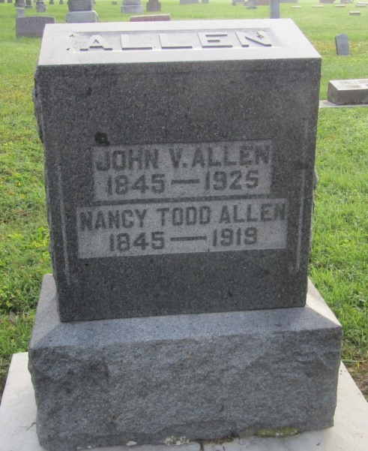

Nancy Allen
in the Indiana, U.S., Death Certificates, 1899-2011
Name: Nancy Allen
[Nancy Todd]
Gender: Female
Race: White
Age: 73
Marital status: Married
Birth Date: 9 Oct 1845
Birth Place: Pennsylvania
Death Date: 21 Jan 1919
Death Place: Ossian, Wells, Indiana, USA
Father: Jacob Todd
Mother: Jane Thomas
Spouse: John V. Allen
Informant: John V. Allen; Ossian, Indiana
Burial: January 24, 1919; Ossian, Indiana

