John V. Allen
May 17, 1845 – December 30, 1925

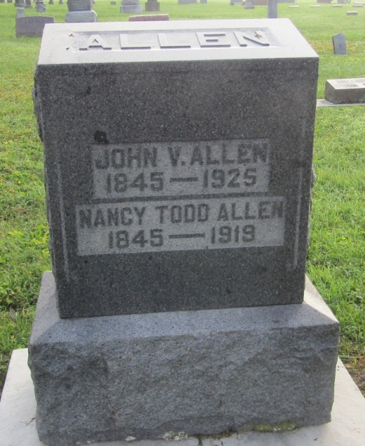

John A Allen
in the Indiana, U.S., Death Certificates, 1899-2011
Name: John A Allen
Gender: Male
Race: White
Age: 80
Marital status: Widowed
Birth Date: 17 May 1845
Birth Place: Ohio
Death Date: 30 Dec 1925
Death Place: Ossian, Wells, Indiana, USA
Father: Stephen Allen
Mother: Eliza Cotton
Spouse: Nancy Todd
Informant: Lida Allen; Ossian, Indiana
Burial: January 1, 1926; Prospect Cemetery

