Charles H. Ady
May 12, 1858 – January 4, 1864

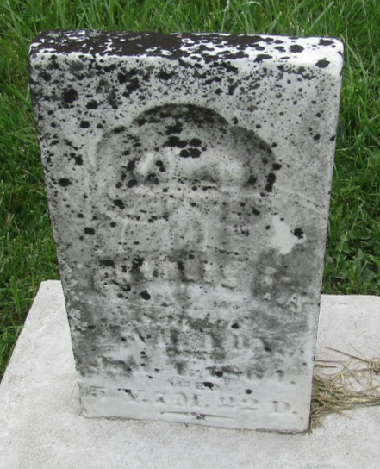

No further information found at this time

