Anna Tonner
September 28, 1882 – January 21, 1932

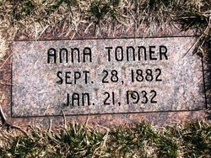
Photo by Barbara Baker Anderson

Anna Tonner is Called by Death
Passes Away at home Southeast of Bluffton Thursday Evening
Miss Anna Tonner, 49, died at the home of her mother, Mrs. Elizabeth Tonner, five miles east and two miles south of Bluffton, at 8:30 o'clock Thursday evening after an illness of four years.
Miss Tonner was born in Wells County, September 28, 1882, the daughter of Jacob and Elizabeth (Baumgartner) Tonner. She had a lifelong resident of this county and a member of the Christian Apostolic church.
Surviving besides the mother are the following brother and sisters: Mrs. John Tschannen, Mrs. Samuel Steffen, Mrs. Daniel Kearn and Jacob Tonner, all of this community. One sister, Mrs. Emil Baumgartner, is deceased.
Funeral services will be held at the home at 12 o'clock noon Sunday and at 1 o'clock at the Christian Apostolic church, with burial in the church cemetery.

Evening News Banner, Wells County, IN; January 22, 1932

