Elias Steffen
August 9, 1899 – March 3, 1901

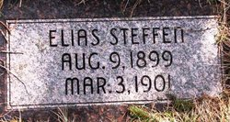
Photo by Barbara Baker Anderson

Three funerals were held Tuesday afternoon at one o’clock at the Neumanese church. The little babe of Anoke Steffen, aged fifteen months, died Saturday night and was buried with the two other members who passed away the morning prior.

Bluffton Chronical, Wells County, IN; March 6, 1901

