Herbert Meyer
March 16, 1895 – October 1, 1910

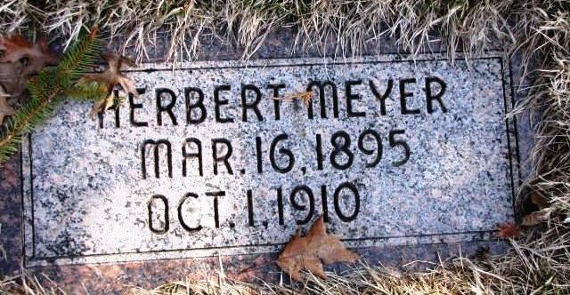

Herbert Meyer, aged fifteen, son of Mr. and Mrs. Jacob Meyer, residing one mile south of Vera Cruz, died early Saturday after two weeks' illness with typhoid fever. He was born and made his life long residence at the present home of his parents. Surviving him are both parents, five brothers and two sisters. The funeral was held Monday morning. The cortege left the residence after a short service at nine o'clock. Services and burial was held at the Neumanese church north of Vera Cruz. - Bluffton Chronicle

Berne Witness, Adams County, Indiana
Friday, Oct. 7, 1910: 613

