Elizabeth (Moser) Meyer
April 5, 1842 – January 31, 1911

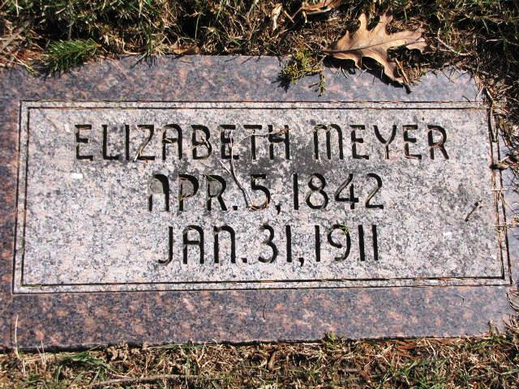

MRS. PETER MEYERS OF VERA CRUZ

Mrs. Elizabeth Meyers, aged 68, passed away about 1 o'clock p.m. Tuesday at her home, just south of the little town of Vera Cruz. She had been sick about four weeks, and her death was due to complications which had left little hope for several days for her recovery.
The decedent, Elizabeth Moser Meyers, widow of Peter Meyer, was a native of Switzerland, and was born April 5, 1842, a daughter of Peter and Elizabeth Moser. At her death she was aged 68 years, 9 months and 2 days.
Her parents emigrated to this country and she was united in marriage to Peter Meyer at Vera Cruz in 1860. They resided for many years on a farm south of Vera Cruz, where Mr. Meyer, the husband, passed away on November 11, 1909.
To the union of Peter and Elizabeth Meyers, there were eight children, all of whom are living.
~ Bluffton Chronicle. -
Funeral services will be held today at the Neumaness church. Mrs. Meyer was a sister of the late Peter Moser who died just a few weeks ago in French tp.

Berne Witness, Adams County, Indiana
Friday, Feb. 3, 1911

