Elizabeth Fiesley
June 6, 1845 – May 24, 1923

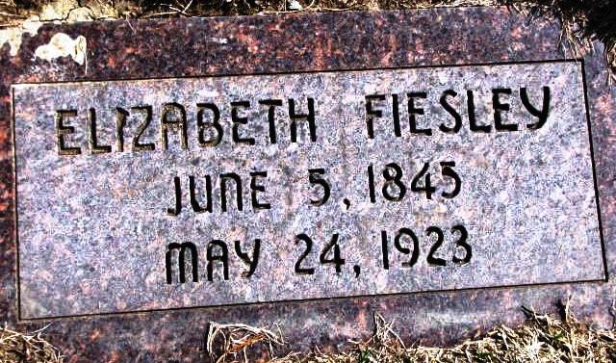

Indiana, Death Certificates, 1899-2011

Name: Elizabeth Feisley
Gender: Female
Race: White
Age: 77y 11m 19d
Marital status: Widower
Birth Date: 5 Jun 1845
Birth Place: Berne, Switzerland
Death Date: 24 May 1923
Death Place: Lancaster, Wells, Indiana, USA
Father: Pfonder b. Berne, Switzerland
Mother: unknown
Spouse: Jake Feisley
Informant: Mrs. Joel Reinhard
Burial: Christian Apostolic May 27, 1923

