Alice Margaret Drayer
May 11, 1911 – September 27, 1912

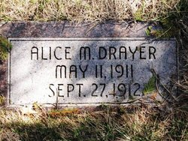
Photo by Barbara Baker Anderson

STRYCHNINE
Caused the Death of Tiny Bluffton Tad

Bluffton, Ind., Sept. 28 [1912] – Alice, the little two-year-old daughter of Mr. and Mrs. Fred Drayer died last evening as a result of eating strychnine tablets, which an older member of the family had left within the reach of the little girl.
The physicians used a stomach pump and other means to save the child, but to no avail. The mother of the child became hysterical and required the services of a physician.

