Hannah Christine (Elzey) Ault-Parker
June 20, 1886 – April 29, 1975

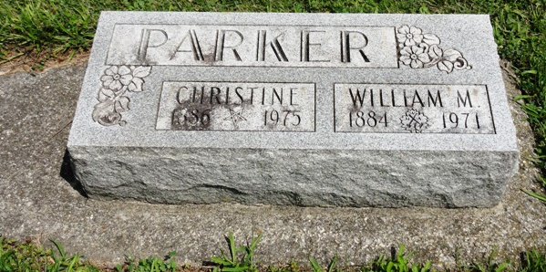
Photo by HoosierGirl88

Hannah Christine Parker
in the Indiana, U.S., Death Certificates, 1899-2017

Name Hannah Christine Parker
[Hannah Christine Elzey]
Gender Female
Race White
Age 88
Marital Status Widowed
Birth Date 20 Jun 1886
Birth Place Indiana
Death Date 29 Apr 1975
Death Place Bluffton, Wells, Indiana, USA
Death Registration Date 1975
Father: Joseph Elzey
Mother: Sarah Sudduth
Informant: Harvey Ault; son; Ossian, Indiana
Burial: May 2, 1975; Oak Lawn Cemetery; Ossian, Indiana

