Mary L. (Myers) Ault
December 6, 1907 – November 20, 2006

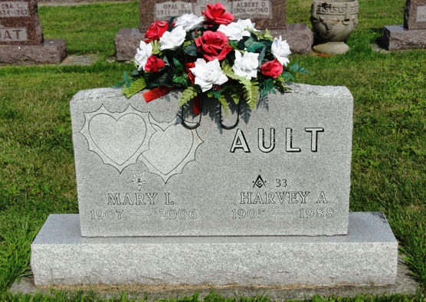
Photo by HoosierGirl88

Mary L. Ault, 98, of Ossian died Monday, Nov. 20, 2006, at Lutheran Hospital, Fort Wayne. Mrs. Ault was a telephone operator for Uniondale Rural Telephone Co. for more than 20 years, retiring in 1966. She was a member of Ossian United Methodist Church and Waynedale Order of Eastern Star #600.
Born on Dec. 6, 1907, in Wells County, she was a daughter of James W. and Elva L. (Kumfer) Myers. Her marriage on June 19, 1926, in Fowler, Ind., was to Harvey A. Ault, who preceded her in death on March 21, 1988.
Survivors include a son, Gene M. Ault of Fort Wayne; four grandchildren; and six great-grandchildren. She was preceded in death by a son, Charles R. "Dick" "Smokey" Ault; two sisters; and a brother.
Visitation is from 5 to 8 p.m. Friday at Elzey Patterson Rodak Funeral Home, Ossian. An Eastern Star service will be held at 7:30 p.m. Services are at 10 a.m. Saturday at the funeral home with Rev. Tim Dilley officiating. Burial will be in Oak Lawn Cemetery, Ossian.
Preferred memorials are to Ossian United Methodist Church.

Unknown source

