Jeanette L. (Kline) Ault
August 24, 1937 – March 18, 2011

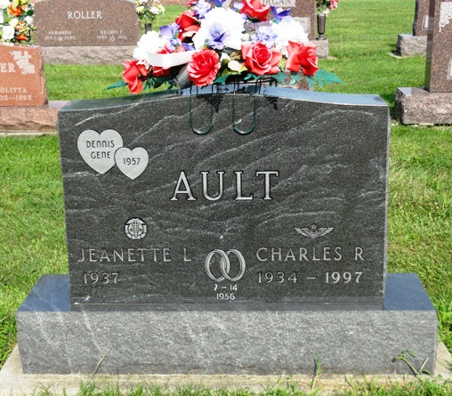
Photo by Kay Bradtmiller

Jeanette Louise Ault, 73, passed away on Friday, March 18, 2011 in her home in Ossian, surrounded by her family. She was born on August 24, 1937 in Fort Wayne, IN to the late Harry and Beatrice (Long) Kline. She was a graduate of South Side High School Class of 1955. She attended Ossian United Methodist Church. She married Capt. Charles “Dick” “Smokey” Ault, USAF, on July 14, 1956 at the First Baptist Church in Ft. Wayne.
Being a military wife, Jeanette moved to several air force bases including Evereux AFB in Evereux, France, Sewart AFB in Smyrna, TN, and Langley AFB in Langley, VA. After military life, Jeanette and her husband settled in Ossian to raise their family.
Jeanette graduated from Fort Wayne Community School of Practical Nursing in 1973 and obtained her Registered Nursing degree from Purdue University in 1985. Her nursing career included work at Caylor-Nickel Hospital, Lutheran Hospital, Markle Medical, and Ossian Healthcare.
She is survived by her children, Anita (Monty) Smart of Huntington, Tom (Barb) Ault of Markle, Dave Ault of Santa Rosa, CA; grandchild-ren, Joseph Ault, Monty J. Smart, Andrew Ault, Robert Smart, Elizabeth Ault; her beloved great-grandson, Wyatt Ault; sister, Juanita Kline of Colorado Springs, CO; and brother Richard Kline of FL.
She was prceded in death by her husband Charles “Dick” Ault; son, Dennis Gene Ault; and sister, Lauretta Miller.
A funeral service will be held at 10:00 am on Monday, March 21, 2011 at Elzey-Patterson-Rodak Funeral Home, 120 West Mill Street, Ossian. Calling hours will also be from 2-8 on Sunday, March 20, 2011 at the funeral home. Memorials may be made to the Ossian United Methodist Church, Visiting Nurse & Hospice Home, or American Cancer Society.

Elzey-Patterson-Rodak Funeral Home, Wells County, Indiana

