Harvey A. Ault
February 10, 1905 – March 21, 1988

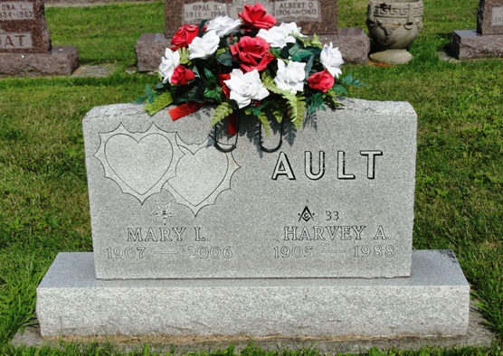
Photo by HoosierGirl88

Indiana, U.S., Death Certificates, 1899-2017
Name Harvey A Ault
Gender Male
Race White
Marital Status Married
Age 83
Birth Date 10 Feb 1905
Birth Place Allen County, Indiana
Death Date 21 Mar 1988
Death Place Ossian, Wells, Indiana, USA
Death Registration Date 1988
Father Charles E Ault
Mother Hanna C Elzey
Spouse Mary (Myers) Ault, informant
Burial 3/25/1988 Oak Lawn

