Gene M. Ault
October 20, 1928 – October 7, 2012

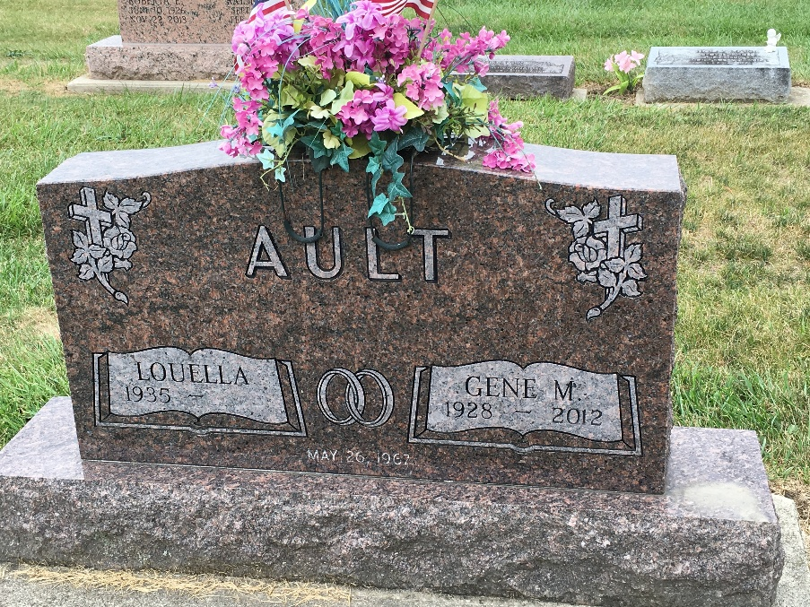
Photo by Barbara Baker Anderson

GENE M. AULT, 83, of Fort Wayne, died Sunday, Oct. 7, 2012 at his home surrounded by his loved ones. Born Oct. 20, 1928, he was the son of Harvey and Mary (Myers) Ault. He graduated from Ossian High School in 1946. He served honorably as a Staff Sergeant in the U.S. Air Force for the Strategic Air Command during the Korean Conflict. He worked at B.F. Goodrich for 31 years as a master mold mechanic. "He loved his Lord, wife, family, and country". He cherished his time at Lake George with his family. He was a member of The Church of Jacob's Well.
Surviving are his loving wife of 45 years, Louella (Jones); daughter, Vicki (Tom) Rolf of Fort Wayne; grandsons, Shea Rolf of Fort Wayne, Nick Rolf of New York, N.Y.; granddaughter, Kelly (Rolf) Hansen of Chicago, Ill.; nephews, David Ault of Santa Rosa, Calif., Tom (Barb) Ault of Markle; nieces, Anita (Monte) Smart of Huntington, Judy Hufnagle of Fremont, Ind.; cousin, Chuck (Anna Lee) Ault of Bluffton and their five sons.
He was preceded in death by his son, Dean Adams; parents; and brother and sister in law, Richard and Jeanette Ault.
Christian graveside service is 10:30 a.m. on Tuesday, Oct. 9, 2012 at Oaklawn Cemetery, 701 S. Jefferson St., Ossian. A celebration dinner will follow at the home of Tom, Vicki, and Shea Rolf.
Preferred memorials are to Visiting Nurse & Hospice Home or Shriner's Children Hospital. Services provided by Elzey-Patterson-Rodak Funeral Home.
Fort Wayne Newspapers, Allen County, Indiana
Oct. 8, 2012

