Dennis Gene Ault
July 29, 1957 – July 29, 1957

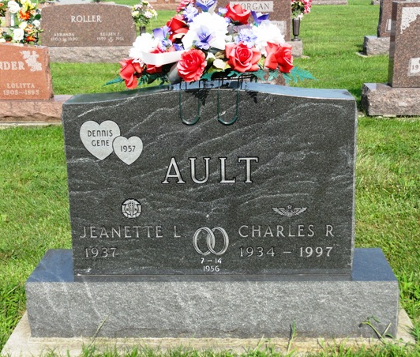
Photos by Kay Bradtmiller

Dennis Gene Ault from tree Ellis-Cunningham
Birth 29 Jul 1957 Fort Wayne, Allen, Indiana, USA
Death 29 Jul 1957 Fort Wayne, Allen, Indiana, USA
Father Charles Richard Ault (1934-1997)
Mother Jeanette Louise Kline (1937-2011)
147201 People 3 Records 3 Sources

